# Experimentations for KG creation with different LLMs

1. Current affairs article: <https://download.oliveboard.in/pdf/December_2023_Bolt.pdf>

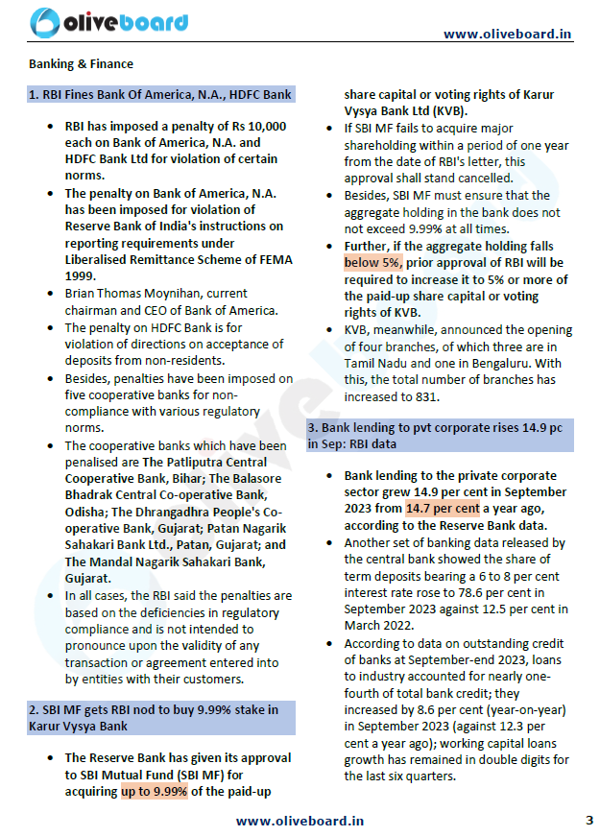

# Experimentation Results

|  |  |  |  |  |
| --- | --- | --- | --- | --- |
| **LLM** | **File name** | **Page number** | **Node count** | **Relation count** |
| **OpenAI-GPT-3.5-turbo-16k** | ../data/December_2023_Bolt.pdf | 3 | 28 | 29 |
| Diffbot | ../data/December_2023_Bolt.pdf | 3 | 0 | 0 |
| OpenAI-GPT-4 | ../data/December_2023_Bolt.pdf | 3 | 27 | 15 |
| Human | ../data/December_2023_Bolt.pdf | 3 | 22 | 25 |

# Human Interpretation

**Triplets:**

[RBI → imposed penalty on → Bank of America,

RBI → imposed penalty on → HDFC bank Ltd,

Bank of America -> penalty of -> Rs 10000,

Bank of America -> violation of -> Liberalised Remittance Scheme of FEMA,

HDFC bank Ltd -> penalty of -> Rs 10000,

Brian Thomas → is Ceo/Chairman of → Bank of America,

RBI → imposed penalty on → The Patliputra Central Cooperative Bank,

RBI -> imposed penalty on -> The Balasore Bhadrak Central Co-operative Bank,

RBI -> imposed penalty on -> The Dhrangadhra People's Cooperative Bank,

RBI -> imposed penalty on -> Patan Nagarik Sahakari Bank Ltd,

RBI -> imposed penalty on -> The Mandal Nagarik Sahakari Bank,

The Balasore Bhadrak Central Co-operative Bank->Located in ->Odisha,

Patliputra Central Cooperative Bank-> Located in -> Bihar,

The Dhrangadhra People's Cooperative Bank -> Located in -> Gujarat,

Patan Nagarik Sahakari Bank Ltd -> Located in -> Gujarat,

The Mandal Nagarik Sahakari Bank -> Located in ->Gujarat,

The Balasore Bhadrak Central Co-operative Bank->violation of ->regulatory compliance,

Patliputra Central Cooperative Bank-> violation of -> regulatory compliance,

The Dhrangadhra People's Cooperative Bank -> violation of ->regulatory compliance,

Patan Nagarik Sahakari Bank Ltd -> violation of -> regulatory compliance,

The Mandal Nagarik Sahakari Bank -> violation of ->regulatory compliance,

RBI → Approves → SBI Mutual Fund,

SBI mutual fund → Intends to acquire -> KVB,

KVB → announced branch in → Bengaluru,

KVB → announced branch in → Tamil Nadu]

**Relation:**

[imposed penalty on, imposed penalty on, imposed penalty on, imposed penalty on, imposed penalty on, imposed penalty on, imposed penalty on, penalty of,penalty of,is Ceo/Chairman of,Approves,announced branch in, announced branch in, Intends to acquire,violation of,violation of,violation of,violation of,violation of,violation of,located in,located in,located in,located in,located in

]

**Nodes:**

[RBI, SBI Mutual Fund, non-residents, Karur Vysya Bank, Hdfc Bank, Bank of America, Central Bank, National stock exchange of India, Interglobe Aviation, Patliputra Central Cooperative Bank, The Balasore Bhadrak Central Cooperative Bank, The Dhrangadhra Cooperative Bank, Patan Nagarik Sahakari Bank, The Mondal Nagarik Sahakari Bank, Liberalised Remittance Scheme of FEMA, regulatory compliance, Brian Thomas Moynihan, Bihar, Orissa, Gujarat, Tamil Nadu, Bengalure, Website]

# KG creation Open AI GPT 3.5 analysis

**Nodes:**

['Central Bank', 'The Balasore Bhadrak Central Co-Operative Bank, Odisha', 'Branch3', 'September 2023', 'Term Deposits', 'Working Capital Loans', ""The Dhrangadhra People'S Co-Operative Bank, Gujarat"", 'Rbi', 'The Mandal Nagarik Sahakari Bank, Gujarat', 'Hdfc Bank', 'Banks', 'Non-Residents', 'Kvb', 'Branch1', 'Karur Vysya Bank', 'Bank Of America', 'Deposits', 'March 2022', 'Industry', 'Www.Oliveboard.In', 'Patan Nagarik Sahakari Bank Ltd., Patan, Gujarat', 'Outstanding Credit', 'Penalties', 'The Patliputra Central Cooperative Bank, Bihar', 'Total Bank Credit', 'Branch2', 'Cooperative Banks', 'Sbi Mf']

**Relationships:**

['reportedBy', 'reportedBy', 'from', 'imposed on', 'penalized', 'penalized', 'penalized', 'penalized', 'penalized', 'imposed by', 'based on', 'not intended to pronounce upon', 'approval', 'stake', 'approval_required', 'has_branch', 'has_branch', 'has_branch', 'shows', 'released in', 'released in', 'has', 'data on', 'at', 'accounted for', 'of', 'in', 'growth', 'last']

**Observations:**

1. Gpt-3.5-turbo-16k was unable to understand that the location of banks should be a separate node.

For example: 'The Mandal Nagarik Sahakari Bank is a financial institution so this should be a separate entity and ‘Gujarat' is the location of the bank. So, two separate nodes should have been created here. But instead it created one node 'The Mandal Nagarik Sahakari Bank, Gujarat’.

1. Some nodes and relationships generated were unnecessary. For example:

Also, It missed the actual relationship for the nodes ‘HDFC bank’ and ‘Bank of America’

RBI → imposed penalty on → Bank of America,

RBI → imposed penalty on → HDFC bank Ltd

1. Contrary to my expectations the LLM did a good job in understanding the short forms. It did not create separate nodes for SBI MF and SBI mutual funds, same for RBI which is Reserve bank of india.

# KG creation Open AI GPT 4 analysis

**Nodes:**

['Transaction', 'Thepatliputracentralcooperativebankbihar', 'Themandalnagariksahakaribankgujarat', 'Reserve Bank', 'Www.Oliveboard.In', 'Karur Vysya Bank Ltd', 'Nonresidents', 'Tamil Nadu', 'Bengaluru', 'Thedhrangadhrapeoplescooperativebankgujarat', 'Patannagariksahakaribankltdpatangujarat', 'Centralbank', 'Kvb', 'Rbi', 'Private Corporate Sector', 'Hdfc Bank Ltd', 'Brian Thomas Moynihan', 'Bank Of America, N.A.', 'Sbi Mutual Fund', 'Termdeposits', 'Banking & Finance', 'Penalties', 'Outstandingcredit', 'Deficienciesinregulatorycompliance', 'Fivecooperativebanks', 'Workingcapitalloans', 'Thebalasorebhadrakcentralcooperativebankodisha']"

**Relationships:**

['contains', 'imposedPenalty', 'imposedPenalty', 'worksAt', 'imposed', 'imposedOn', 'basedOn', 'intends to acquire stake', 'approves', 'regulates', 'hasBranchIn', 'hasBranchIn', 'reportsLendingGrowth', 'releasedData', 'releasedData']

**Observations:**

1. Gpt 4 is removing space in some of the nodes like 'Thepatliputracentralcooperativebank'. For others it isn’t doing the same. So inconsistency can be observed.
2. Does a better job than gpt 3.5-turbo-16k at finding relationships. For example,

1. Gpt 4 did a better job at identifying the financial concepts. For example,
2. A group of blue circles with white text

   Description automatically generated

The llm was not able to make relationships for some nodes like the bank names such as 'Thepatliputracentralcooperativebankbihar', 'Themandalnagariksahakaribankgujarat'.

1. Gpt 4 is able to identify the locations better than gpt-3.5-turbo. Gpt 4 has generalized it better. For example,

1. Gpt 4 was able to understand that RBI imposes penalties on 5 cooperative banks but it couldn’t map the banks’ names.

# Conclusion

The purpose of this experimentation was to evaluate the performance of knowledge graph creation by LLMS like Diffbot, OpenAI GPT-3.5-turbo-16k and GPT-4.

While Diffbot by langchain couldn’t extract any nodes and relationships in the sample pdf page, Open AI gpt 4 did a great job at identifying nodes and relationships. With better prompt engineering gpt-4 results can be improved upto an extent. While gpt-3.5 extracted more nodes and relationships in comparison to gpt-4, but gpt-4 did a better job at creating meaningful results.